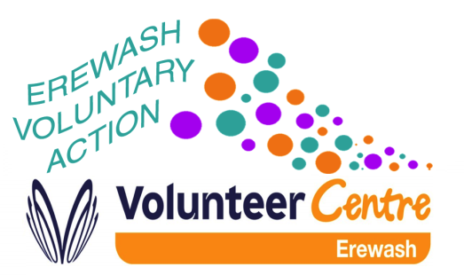
COVID 19 - FUNDING and GRANTS INFORMATION
October 2020 – Edition 2
There are several grant aid opportunities that have deadlines fast approaching. These are listed below. The November edition of the funding bulletin will be published in early November.
PwC ColourBrave Charity
Grants are available for black led social enterprises and charities with ethnic minority beneficiaries in the UK. UK based social enterprises and registered charities can apply. Funding will cover the range of costs associated with the work of the eligible organisation.
There are five levels of funding available grants of up to £2,000, grants of £2,000, grants of £5,000, grants of £10,000 and grants of £25,000
The deadline for applications is 30 October 2020.
For further information: https://www.pwc.co.uk/who-we-are/our-purpose/empowered-people-communities/community-engagement/pwc-foundation/colourbrave-charity-committee.html

The Prince’s Countryside Fund
Funding is available for locally focused, legally constituted not-for-profit organisations who are working to create resilient communities across the UK in the wake of the pandemic.
Grants are available of up to £10,000 for one year. The average grant is expected to be around £8,000 and projects must be completed within one date of their start date and no later than 31 March 2022.
The theme is rural community resilience which refers to projects that will allow the community to survive and thrive, especially when facing a situation that affects every day rural life. The funding is for projects that protect or boost community assets and enterprises or otherwise strengthen the sense of community. Some match funding is expected.
The deadline for applications is 3 November 2020 at 12 noon.
For further information: https://www.princescountrysidefund.org.uk/grant-giving-programme/grant-programme

BAME Healthy Communities Surviving Covid 19
The African Health and Policy Network are making three levels of grant funding available. They are particularly interested in supporting wellbeing projects by BAME led organisations that demonstrate they are people and service centred. For this fund a BAME led organisation is a voluntary or community organisation, charity or other form of social enterprise having a majority of the governing body from BAME communities.
There are grants of up to £5,000 available, grants up to £10,000 and micro-grants of between £500 to £1,000
The closing date for applications is 30 October 2020 at midnight.
For further information: https://www.ahpn.org.uk/grants

East Midlands Airport Community Fund
East Midlands Airport have now fully reinstated the independent EMA Community Fund Committee, which will next meet on 18th November 2020 to review all eligible applications. The Airport Community Fund is dedicated to bringing lasting benefit to those areas most affected by the airport’s operations. It forms part of our Community Relations programme, committed to minimising the impact airport operations have on surrounding communities.
The maximum grant the Community Fund will make is £2,000 for anyone project. There are specific geographical areas of benefit and applicants are advised to check their project is in an eligible area.
Community groups and organisations can apply.
The next deadline for applications is 3 November 2020
For further information: https://www.eastmidlandsairport.com/community/supporting-the-local-community/charitable-giving/

Postcode Dream Trust – Postcode Recovery Fund
Grants are available for charities with innovative ideas to help communities across Britain recover from problems highlighted or exacerbated by the pandemic.
Grants are available of between £500,000 and £1 million.
The funding is for charitable organisations to develop projects that address societal issues raised by the pandemic. There are six priority areas – educational inequalities, homelessness, domestic violence, health and wellbeing, social exclusion and poverty.
The deadline for applications is 30 October 2020 at 5.30 pm
For further information: https://www.postcodedreamtrust.org.uk/postcode-recovery-fund/

For any further details please contact:
Catriona Paterson – Development Worker
Erewash Voluntary Action
Granville Centre
Granville Avenue
Long Eaton
Derbyshire
NG10 4HD
Tel: 0115 9466740
Email: catriona@erewashcvs.org.uk

www.erewashvoluntaryaction.org.uks c

