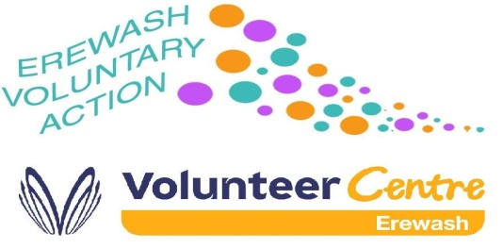
Erewash Voluntary Action - Job Application

Application for the post of: Development Worker - Mental Health and Suicide Prevention
Closing date for applications: 9th February 2022 4pm
Interviews for this post will be held on 16th February 2022
If you have not been contacted by this date, you application has not been successful

Return your application by email to : stella@erewashcvs.org.uk
Or mark your envelope Confidential application for employment and return by post to:
Mrs Stella Scott
Erewash Voluntary Action
The Volunteer Centre
Granville Ave
Long Eaton
NG10 4HD
If you have any general enquiries about your application, please contact:
Mrs Stella Scott Tel: 0115 946 6740
Please state where you heard about this vacancy ..................................................................................
Declaration
I declare that, to the best of my knowledge, all the information in this application form is true. I understand that if I provide false information my application will be disqualified. If evidence of any of this is only discovered after my appointment I realise I can be dismissed without notice.
Signed | Date

- Current and previous employment
- Current or most recent employer
Name of employer

Type of business

Job title

Main duties
Annual Salary/wage

Start Date

Date left (if applicable)

Notice period required

Reason for seeking other employment/reason for leaving

- Employment history

Name of employer | Job title | From | To | Reason for leaving
- Education, training and skills

Date(s) | Provider/Organisation/Trainer | Course title | Qualification gained  (if applicable)
- Skills, Knowledge and Experience
Please list each of the criteria in the person specification and describe how you meet each of the criteria giving specific examples. In addition to information about paid employment include unpaid experience or activities you have undertaken which you feel are relevant to the job. You may wish to refer to the Application Guidance provided in this application pack.

You may use a separate sheet of paper to answer this question and attach it to your application.

- Criminal Offences
- The Rehabilitation of Offenders Act 1974 is intended to assist people who have been convicted of a criminal offence but who have not re-offended since. This allows most convictions and all cautions, reprimands and final warnings to become ‘spent’ after a certain period. The length of the rehabilitation period depends on age at the time of conviction and the sentence received.
- Spent offences do not need to be disclosed when applying to most jobs. However, some jobs are exempt from the Rehabilitation of Offenders Act, which means that spent (and unspent) convictions, cautions, final warnings and reprimands must be disclosed and the job may require a Standard or Enhanced Disclosure and Barring Service check (formerly known as a Criminal Records Bureau or CRB check) containing your full criminal record. Recent legislation (May 2013) allows some spent offences to be ‘filtered’ from DBS certificates, thereby not requiring their disclosure for jobs subject to Standard or Enhanced DBS checks.
- If you would like more information or advice about the Rehabilitation of Offenders Act, spent and unspent convictions, disclosure and your rights contact NACRO’s Resettlement Advice Service, Tel: 020 7840 121, email: helpline@nacro.org.uk or visit www.nacro.org.uk
- The letter enclosed with the application pack for this post will state whether or not the post is exempt from the Rehabilitation of Offenders Act and whether nor not a standard or enhanced Disclosure and Barring Service check will be undertaken for the successful candidate.

- If you declare a conviction you may be asked formal questions about it at interview if shortlisted. A criminal record is not necessarily a bar to obtaining employment with Erewash Voluntary Action, which will consider the nature and circumstances of the offence, number of convictions, how long ago they took place and relevance to the job you are applying for.
Do you have any convictions, cautions, reprimands or final warnings that are not ‘protected’ as defined by the Rehabilitation of Offenders Act 1974 (Exceptions) Order 1975 (as amended in 2013)? ☐ Yes ☐ No
If yes please state the:
Nature of offence
Date of conviction
Penalty
- If you wish, please enclose a letter with more details about the nature and circumstances of your offence(s), addressed to the Chief Executive Mrs Stella Scott at the address given on the front of this application form and marked ‘private and confidential’.

